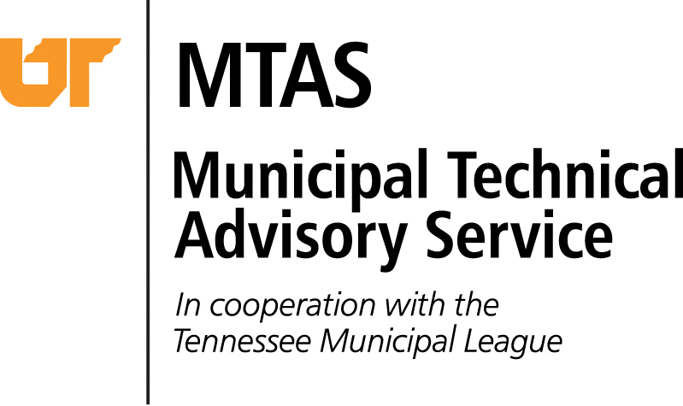
600 Henley Street, Suite 120

Knoxville, Tennessee 37++6
Phone: 865.974.0411
Fax: 865.974.0423
jonesj@tennessee.edu
www.mtas.tennessee.edu

From: Josh Jones, Legal Consultant

Date: Tuesday, February 11, 2014

Re: Residency Requirement

Question: What time period is covered by the one-year residency requirement of T. C. A. § 6-3-103?

Answer: In a city governed by the general law mayor aldermanic charter, a candidate for the Board of Mayor and Aldermen must have been a resident for the one-year period immediately preceding the date of the actual election.

The provision in question, T. C. A. § 6-3-103(a), reads:
(a) No person shall be eligible for the office of mayor unless such person has resided within the municipality for at least one (1) year next preceding the election.
The plain language reading of this provision would require a candidate to establish residency no later than one year immediately preceding the date of the election.
The only relevant law I can find on the question is an Attorney General opinion looking at the residency qualifications for a candidate to a county legislative body. Tenn. Op. Atty. Gen. No. 78-252 (June 19, 1978). The residency requirement at issue was not durational, it merely required that a member to reside within the district. The Attorney General relied on Comer v. Ashe. 514 S.W.2d 730 (Tenn. 1974) in determining that:
…as long as a successful candidate meets the qualifications of residing in a district that he will represent, and otherwise being a qualified voter on the day that he takes office, he may assume the duties of a county commissioner and a member of the county legislative body.
This is a direct parallel to the situation in your city. Under this same reasoning a candidate for the Board of Mayor and Aldermen must meet the residency requirement on the day of election.

