City of Townsend

Competitive Sealed Proposals

Community Plan with a Parks and Recreation Master Plan
  - February 7, 2023

Introduction
The City of Townsend is soliciting responses from qualified firms to update its Community Plan or Comprehensive Planning document to include a Parks and Recreation Master Plan as described herein. This plan will serve the Townsend community in guiding decisions for livability, economics, mobility, recreation, employment, and city services. This plan will assist our city leaders in making decisions for the future of our community and to provide cost effective and expeditious provision of public services including but not limited to transportation, recreation, public safety, and utilities.
The selected consultant team will identify and assess local conditions and needs, analyze demographic indications, growth patterns and identify areas for improvement, and formulate implementation strategies to instill the vision of the community. The planning process should build on past plans and develop a vision for the community through public participation that encompasses the unique character of Townsend as the “Peaceful Side of the Smokies.”
The city is interested in firms that are experienced in high-level professional services including: research and analysis of historic, present, and future land use patterns; market analysis; mapping; creative methods of public engagement and community visioning; development of recommendations for successful plan implementation; and document preparation.

Competitive Sealed Proposal Release
Deadline for Submittal
Evaluation of Responses (Community Plan Advisory Committee)
Interviews
Recommendation of Advisory Board/ Contract Negotiations
Board of Commissioners Action-Award of Contract
Commencement of Project

All work shall be completed in accordance with applicable City standards and within the agreed upon timeline, with plan delivery expected 12-18 months from commencement of project.

Community Description
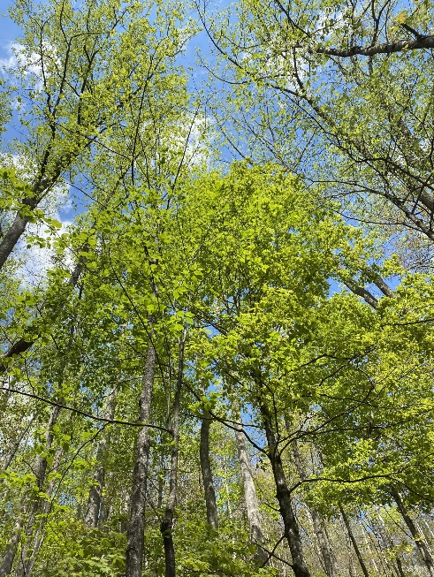
Townsend, a city in Blount County, located in East Tennessee, is one of the three major gateways to the Great Smoky Mountains National Park which hosted more than 14 million visitors in 2021. Townsend is situated in Tuckaleechee Cove along US 321 and comprises just 2.2 square miles. The US Census Bureau established the population just over 550.
Visitors are drawn to Townsend by the clean mountain air and majestic scenery and all the outdoor adventures Townsend, and the Great Smoky Mountains National Park have to offer. The community wants to continue to be a tourist location and still maintain the heritage and culture loved by its residents.
The City of Townsend is wanting to develop a land use plan and a service delivery strategy with a vision that encompasses the unique character of our city, the “Peaceful side of the Smokies.”

Project Description
The City of Townsend is looking to create a Vision statement and a collective understanding of the identity of its purpose as a gateway corridor to the Great Smoky Mountains National Park. The new Community Plan or Comprehensive planning document will incorporate existing zoning regulations with new proposed zoning overlays or districts and policies, most likely for the properties fronting on US 321 or the 32 Corridor. And it will utilize the existing infrastructure for a street plan. The plan will be a 20-year guide for future development that considers residents, businesses, and infrastructure. It will be a policy tool that aids and directs the Board of Commissioners and Planning Commission in decisions relating to land use, public investments, services, and fiscal priorities. The plan should take into consideration demographic and market trend analysis and structure future growth utilizing sound planning principles while supporting citizen desires. The plan will outline the potential challenges with current trends and policy, while identifying alternatives for action. Therefore, these alternatives should help guide the city in a direction that protects our health and natural environment, and makes our community more attractive, economically stronger, and prepared with a service delivery strategy. The new document will build upon the existing document, the 2010-2020 Land Use and Transportation Plan that was adopted November 14, 2013 (https://www.cityoftownsend.com/wp/wp-content/uploads/2019/09/landuseplan-2010FINALwithIllus.pdf.) A major emphasis will be placed on community engagement to learn about current community values, needs and desires, developing a business statement that can incorporate market realities and plan for community growth. Furthermore, it is a priority to establish guiding policies that will be used to implement the plan. Once the plan is adopted, this is the element that should be used continuously as individual developments are reviewed to act as a guide to ensure proposals are consistent with the objectives of the plan.
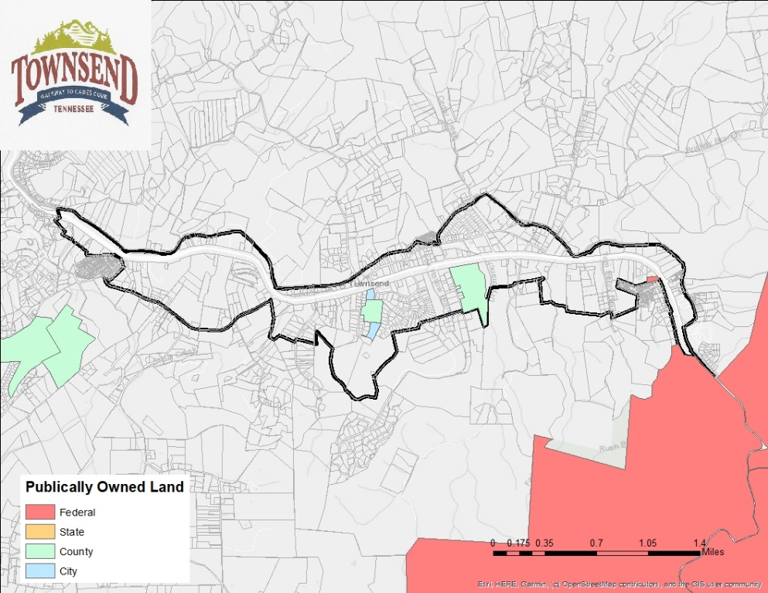
In addition to a community-wide plan, to provide outdoor amenities and better parks for our community and its visitors, the city must create a Parks and Recreation Master Plan to address these needs and set a foundation to pursue grant funding to expand our current system. The City is currently drafting an ordinance to establish a Parks and Recreation Advisory Board to assist with policies and events within our park system and provide guidance and recommendations to the Board of Commissioners.

It is the intent of the city to require the firm to work closely with the Townsend city planner and staff of the East Tennessee Development District (ETDD) and the City of Townsend Community Plan Advisory Committee (CPAC) for preparation and submission of the updated Community Plan and Parks and Recreation Master Plan to the City of Townsend Planning Commission for endorsement by the City of Townsend Board of Commissioners.

Project Scope
The purpose of developing this plan is to chart the course for a more attractive, economically successful, vibrant, and safe Townsend while protecting its natural resources, culture, and heritage. The Plan should include the following:
- Growth pattern and impact assessment
- Demographic and market trend analysis- Analyzation of current and future trends, including advancements in technology, changes in consumer and workplace behaviors, and local and regional market trends that may impact local land use and the economy. It should include an examination of demographics and market influences, land use and zoning, workforce housing, transportation, infrastructure needs, public safety abilities and vulnerabilities, the natural environment, recreation, and public education facilities and future need. The market study should provide a regional context, as well as an overview of Townsend’s history. Ultimately, the results of the market study should be used to justify and explain the Community Plan recommendations that will eventually be made.
- Level of Service Guidelines to measure performance
The following elements should be included in the plan:
- Vision Statement
- Natural Features
- Socio-Economic Trends
- Land Use and Transportation Inventory and Analysis
- Public Service Elements including Public Works, Utilities and Public Safety
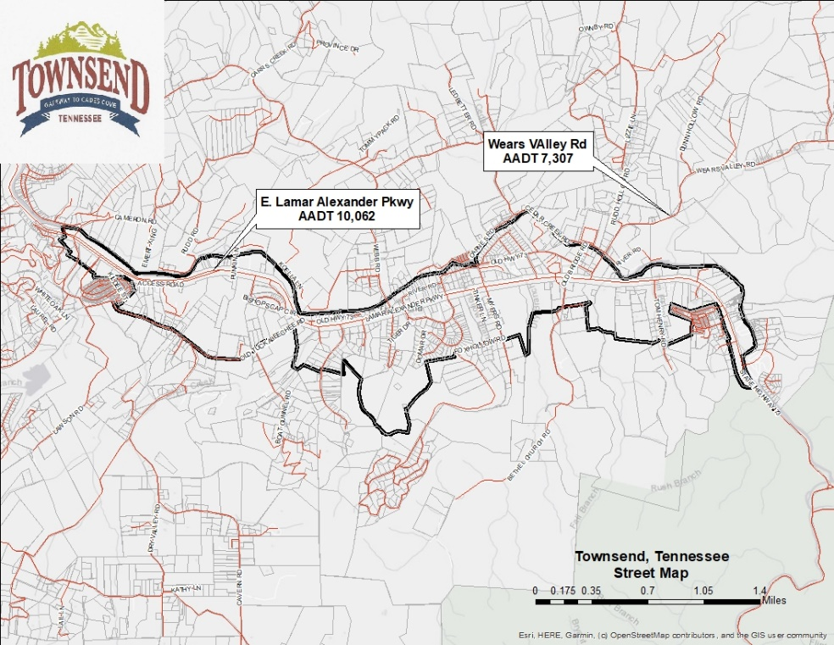
- Housing
- Conservation and Natural Resources
- Open Space and Recreation
- Community and Cultural Facilities
- Historic Preservation
- Community Design
- Implementation and Funding Program
- Development Plan and specify policies
- Implementation Methods

Final Plan Document and Deliverables
In addition to the above elements and goals, project deliverables should include the analysis and policy direction on the following:

  - A future land use map that provides general guidelines for different types of land uses and recommendations for improving zoning district standards, such as overlay districts and newly created or refined districts, so that land use and transportation can be more fully integrated to meet City goals.
  - Additional relevant maps and other graphic illustrations that convey important trends and information related to and including, but not limited to, transportation, infrastructure, parks, open space, recreation, conservation and natural resources, and historic preservation.
  - An extensive community engagement process that includes public workshops, charrettes, community input and comment, and coordination with City staff on additional public outreach methods using social media, a project webpage, etc.
  - Presentation of draft plans to the Planning Commission, City Commission, and all other committees or groups as deemed appropriate.
  - Presentation of the final plan draft to the Planning Commission for recommendation and to the City Commission for approval.
  - Editable electronic copies of the draft and final Community Plan and Parks and Recreation Master Plan, in addition to editable electronic copies of all maps, charts, tables, etc., in all formats approved by the city (e.g., Word, Excel, and InDesign).
  - An implementation plan will be prepared that outlines key projects, estimated costs, potential timing/phasing, funding sources and programs.

Submission of Proposals
To be considered, Proposers must submit a complete response to this Competitive Sealed Proposals using the format provided. Proposals must include a statement as to the period during which the proposal remains valid, but for purposes of this CSP, the period must be at least ninety (90) days.
Five (5) printed copies and (1) original along with one (1) electronic copy in a single .pdf file on a flash drive of the entire proposal package shall be enclosed in a sealed envelope plainly identified in the upper left-hand corner with the company’s complete name and address and in the lower left-hand corner with "Competitive Sealed Proposal-TOWNSEND COMMUNITY PLAN”. Proposals shall be received by the City Manager 123 Tiger Dr., PO Box 307, Townsend, TN 37882 on or before 4:00 p.m.____________ Telephone or facsimile offers will not be accepted.
Proposals must be signed in ink by the agent or person authorized to bind the Proposer to its provisions. Unsigned offers will not be accepted and will be declared non-responsive.

Proposal Submittal Format
Vendors shall use the following format for the preparation and submission of their proposal. Failure to follow this format may be just cause for rejection of submittals. Cost of preparation of qualifications is the sole responsibility of the vendor.
Part 1 – Technical Expertise
Firms are to provide their overall quality and completeness of qualifications and experience relating to the services requested in this RFQ. Respondents must describe the experience of their firm in providing the requested Community Plan and Implementation experience. Firms must provide a narrative description of the organization including years in business, principal parties, description of the firm, organizational chart, office locations, and individual responsible for contracting services/authorized signatory. Provide one-page resumes and licenses/certifications of key personnel that will be assigned to the project and list tasks to be performed. Key personnel assigned to the project should be clearly marked on the firm’s organizational chart. Provide information on proposed subcontractors, if applicable, including firm qualifications, resumes, licenses, and proposed work, and other pertinent information.
Firms must provide a statement of understanding that demonstrates mastery of a comprehensive plan development. Firms must include in this statement the unique qualifications that differentiates their firm from others and qualifies them to lead the project for the City of Townsend.
List and describe in detail three (3) examples of projects similar in scope to this RFQ completed within the last five (5) years. Include project name, location, time, brief description of scope of work, total contract cost, number and type of facilities, and current contact with telephone number and current e-mail address.
Please include a link to an electronic copy of up to three sample Comprehensive Plan documents from comparable municipal projects.
Provide Financial Security Information, including litigation history and the most recent audited financial statements. Financial statements may be provided in electronic format on the requested flash drive due to possible size of document. Note any pending or settled lawsuits in which the consultant or team firm was involved during the past 5 years.
Part 2 – Project Understanding/Approach
Demonstrate a clear understanding of the project, developing a community-wide plan with specific elements and a Parks and Recreation Master Plan. Provide a concise summary of the team’s approach to the project. If your proposal is based upon any variation to the scope of work (reduced or additional services), please outline any clarifications or modifications.
Part 5 – Collaboration and Public Participation
Demonstrate an ability to work collaboratively with and facilitate consensus among a variety of government, neighborhood, and business interests.
Part 6 – Implementation Plan
Provide an implementation plan and timeline to meet the requirements of developing a community plan, master plan for parks and recreation and specific studies and analysis. This should include a master schedule listing all tasks/phases, major milestones, and completion time for each. Firms should include a statement on their commitment to completing the project and resources available to ensure a successful project that is on-time and within budget.
Part 7- Project Cost
Submission should include a detailed cost breakdown for the services requested. This should include the hourly rates for personnel or personnel categories. It should identify the total cost for completing each defined work task separately including direct and indirect costs. The proposal should be signed by the person authorized to submit responsible for the decisions as to costs and services being offered

Evaluation Criteria and Selection Procedures
The selection process is based on the qualifications of the consultant to complete the project on time, within budget, and understanding of and approach to the project. It is the intent of the City of Townsend to down select from the qualified entries at least three consultants to conduct personal interviews.
An Evaluation Committee representing the City of Townsend will evaluate all submittals. Tentatively, the selection members identified for this evaluation process are the members of the Community Plan Advisory Committee.
The selection team will review the Consultant’s submittals and will make its selection criteria based on the following:

Evaluation Criteria | Total of 100 Points
Technical Approach to addressing the Scope of Work | 35
Key Personnel and Qualifications | 30
Previous experience in comprehensive plans | 20
Grasp of project requirements | 15

Work Assignments
The city will develop task orders for each phase of the project. The cost for each task order will be negotiated prior to approval by the Townsend City Commission.

